**JavaScript Performance optimization**

Use mono morphic arguments to the methods

1. **Monomorphic? :** The argument contains only one Shape/Hidden Class, it reflects in the compiler, I know this shape I optimized it for you and I can use the same cached method.
2. **Polymorphic? :** The argument contains know shapes, I still get from known optimized function I still get from the caches, but not performant as Monomorpihic, it can handle up to 4 types of shapes.
3. **Megamorphic?** : I cant get from the cached functions, hence you are passing different kinda shapes, from compiler difficult to recognize the patterns to optimize it.

**Notes:**

* Momomorphic is 100 times faster than megamorphic, so try to use it.
* Polymorpic interanally switch the shapes to recogise wether it is well known function or not.

**Optimization through inline cache**

This optimization can be handled by the optimization compiler in V8, this is how optimization was done under the hoods



**Shapes/Hidden Classes**

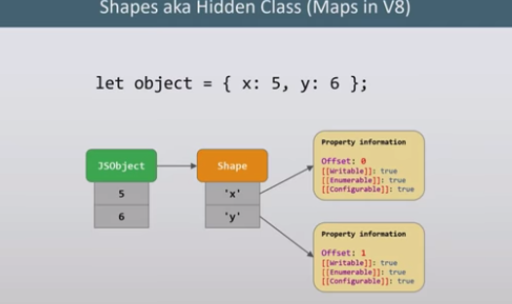





**NOTE:** The transition chain is a long process to execute all upwards to find the share of the key in the object, that where the IC ( Inline Cache ) is to the rescue.

**Angular/React related things**

Viewnodes and fibers (This is how templates were transformed into a data structure before rendering)

**Bit Fileds (bit vectors)**

Is the bit formatted array in the compiler, it’s a C++ concept. These frame works were use this to store the side effects (CRUD) in DOM.

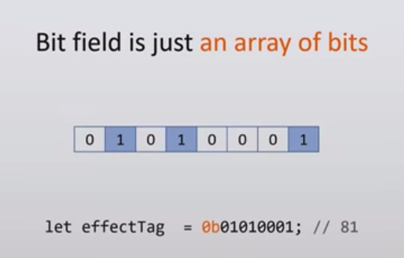

The following is the representation how react uses the bit fields in fibers to make side effects.

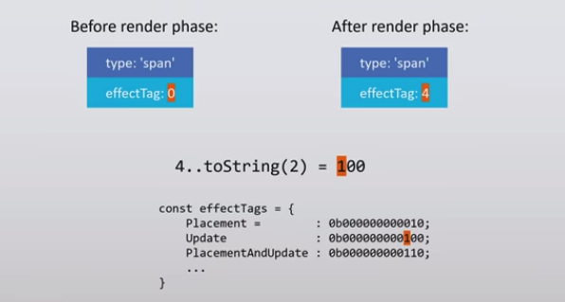

Advantages of bit fields:

* No need to allocate memory for JS objects and shapes
* Simplified garbage collection
* Smaller and contiguous memory usage, it is processor friendly operation
* Fast access using simple bitwise operator, it is processor friendly operation

**Bloom filters**

Probabilistic data structure it returns only “no” or “maybe”. It uses in the DE in angular to use the Hierarchical injections to find out the dependency. In the hoods by hashing to the bitfields.